Introduction to Software Engineering use case Project Team :
- Aryan Zaheer- 4350/BSSE/F-21/SEC-B
- Suleman Faiz - 4349/ BSSE/F-21/SEC-B
- Usama Umar- 4356/ BSSE/F-21/SEC-B
- Saad Ishaq-4355/ BSSE/F-21/SEC-B
- Mohsin Waheed-4335/ BSSE/F-21/SEC-B

“Go Solutions”

“Your safety is our priority”

What is “Go Solutions”?
Go solutions is a search engine. It’s basic purpose is to provide web services and it allows the parents to give their children access to the web making sure that the don’t get tricked while using internet. This project is designed keeping in view the increasing rate of cybercrimes with teenagers.

“Go Solutions” requirements

ADMIN:

Admin is the service provider. Admin has faculty members responsible for various functioning of the search engine. Admin can control the whole system.
Admin can manage data that is
● Common Data: which is non restricted for all users.
● Sensitive Data: Which is restricted for under ages and some is also restricted for adults.
● History Management: admin can also manage history and can store it in a private storage for security purposes.

Transaction details:
When user will pay the charges to bank will update the transactions in the application. Admin can check those updates anytime. In case of any issue, he can consult to bank management team.

PARENTS:
Requirements from Parents:
- Parents will need their own CNIC and child CNIC for registration. Once registration is completed, they can keep check and balance on their child.
Role:
2. In case of any sensitive search by child, parents will receive an alert through E-mail or text massage. They can restrict that search.
Transactions Process:
3. Once parents have paid charges, then they can check transaction history online.

CHILD:

- Child have only access to login, registration will be done by the authentication of parents.
- Child can use search engine and surf through common data.
- If child searches some irrelevant data or some risky websites that are banned in that particular region, parents will be informed through an alert about this action.
- Child have access to see history and also update account.
- When child reaches legal age, he can update this account through the authentication of parents.

BANK:
Bank will play central role with the among customer and service provider, once parents have paid charges bank will generate the transaction details and update it on application. A bank team will be specific for this process whose job will be to provide integration among the users and provider.
a
Use case Diagrame:
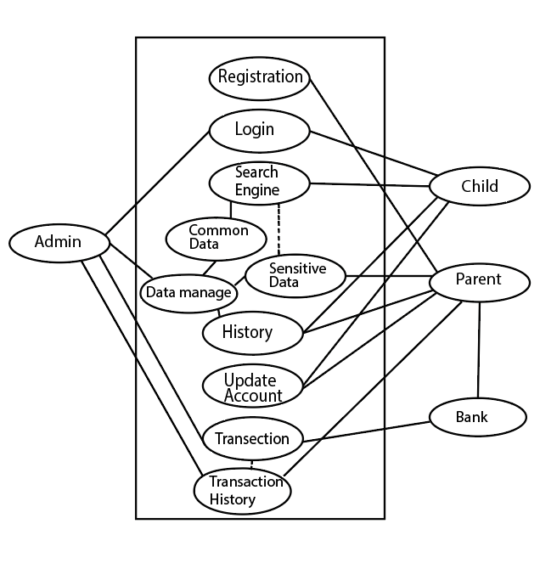

Domain Model:
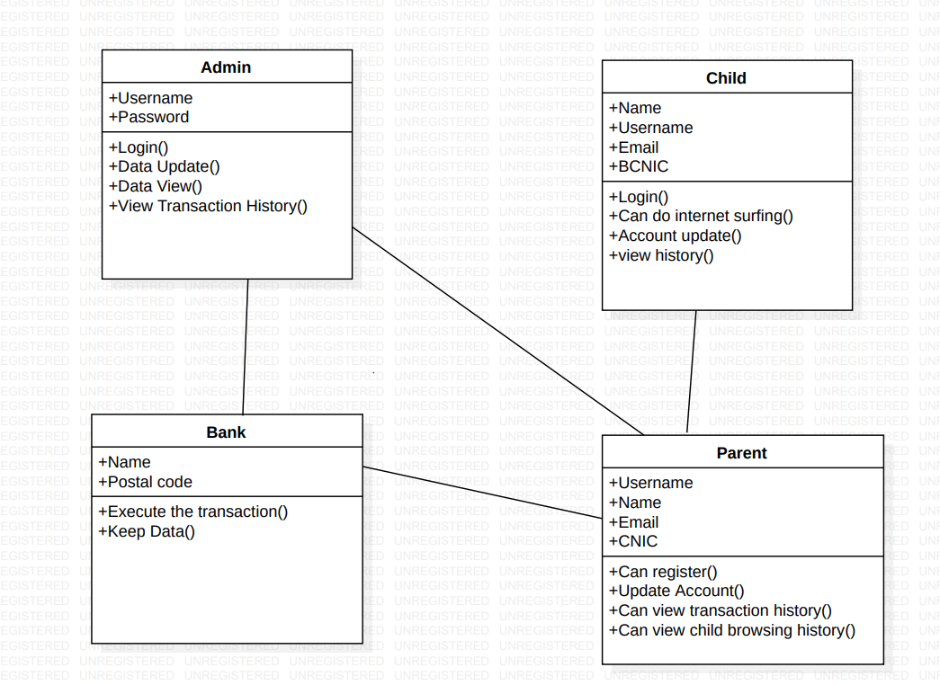

Characteristics:
Admin:
• Admin can login thorough admin portal, it can manage the whole data and web servers. It can keep the whole data of user for security purposes and can react to certain data accordingly.
• Admin will receive all transaction details through his integration team i.e working with bank. It can take proper actions against the uncertain situations.
Parent:
• Parent will have to provide their CNIC’s along with the child CNIC. The registration of account is not possible without the authentication of parent.
• Parent can pay charges online and offline and can check transaction updates on application’s website.
Child:
• Child will be use the login page of the account that has been registered by the parents. His all searches will be private except the sensitive searches.
• Any illegal site will be prohibited and parents will get to know about that.

Bank:
• Bank will have certain team working with him that will send all the transactions detail on website and will update there.

Assignment no 1
Subject name: Introduction to software engineering
Student name :M.Aryan Zaheer
Reg no:FBAS/BSSE/4350/f/21-B
Question no 1;
Describe the waterfall model and list the stages of waterfall model for software
development and list its three advantages and dis advantages?
Answer:
The Waterfall Model is a classical model used in System Development Life Cycle
(SDLC) to create a system with a linear and sequential approach. It is also referred to as
a linear-sequential life cycle model.
Advantages:
1. Reinforces good coding habits to define before design and then code.
2. Allows for early design or specification changes to be made easily.
3. Clearly defines milestones and deadlines.
Disadvantages:
1. Reduces efficiency by not allowing processes to overlap.
2. No working product is available until the later stages of the life cycle.
3. Not ideal for complex, high risk, ongoing or object-oriented projects.
List of the stages:
1. Requirement Gathering and analysis
2. System Design
3. Implementation
4. Integration and Testing
5. Deployment of system
6. Maintenance
Question no 2:
List down the stages of SDLC and describe each stage in one phrase each?
Answer:
1. Planning and Requirement Analysis :Most importance stage in which senior
member of software team take input from user.
2.System Design : Based on the requirements in SRS desired features and
operation in detail are specified and documented in a DDS(Design Document
Specification)
3. Building or Developing the Product : In this stage of SDLC the actual
development starts and the product is built.The programming code is generated
as per DDS during this stage.
4. Defining Requirements : Once the requirement analysis is done the next step is
to clearly define and document the product requirements and get them approved
from the customer.
5. Testing the Product : This stage refers to the testing of the product where
products defects are reported, tracked, fixed and retested, until the product
reaches the quality standards defined in the SRS.
6. Maintenance: There are some issues which come up in the client environment.
To fix those issues, patches are released. Also to enhance the product some
better versions are released. Maintenance is done to deliver these changes in the
customer environment.
Question no 3;
Write one user level and several system requirements?
Answer:
User requirement:
Any library member should be able to search books by their title, author,
subject category as well by the publication date
System requirement:
There are two type of system requirements:
Functional requirement:
1. Maintain stock: : It must enter details with respect to new book, handouts,
magazines and so on .The stock details are refreshed every single time another
stock arrives or when a thing is taken out.
2. Providing Identification number: The framework gives one of a kind distinguishing
proof number to every thing independently. It ought to likewise give separate
recognizable proof number to its individuals
3. Manage Periodicals : It means stocks that arrives on daily basis like newspapers,
magazines. the system manages them efficiently.
4. Reservation :One of the most significant capacity of a Management framework is
that it can assist individuals with reserving a specific thing which they need from
anyplace by utilizing their enrollment number
Non-Functional requirements:
Performance
The Server would be able to perform desired tasks in reasonable unit of time.
Reliability
The Server would perform desired tasks as expected. The system does its work
with more accuracy like user registration to the system, user validation and
authorization, book search and issue operation, return status , and updating the
database by synchronizing between database and application.
Security
The system would provide access to only legitimate users. It will be secure on
network and only authorized person can use it.
Scalability
The proposed system would be scalable to support extended number of users.
Question no 4
Draw use case diagram and domain model for university management system?
Answer:
Use Case Diagram
Domain Model
Question no 5:
Write the non- functional requirement of the following projects?
Answer:
Bike Racing Game:
• Game should take 20 seconds for loading
• Game should have 3D reality graphics
Online Banking :
• Software should provide its services 24/7.
• Security of client data must be handled very carefully.

